## A

## PROJECT REPORT ON

## MusiRELM – Music Player Website

## SUBMITTED TO



Maharashtra Education Society’s

MES SENIOR COLLEGE, PUNE

Approved by AICTE, New Delhi

&

Affiliated to SAVITRIBAI PHULE PUNE UNIVERSITY

IN PARTIAL FULFILLMENT OF

BACHELOR OF BUSINESS ADMINISTRATION

(COMPUTER APPLICATION)

(Academic Year 2024-25)

SUBMITTED BY

Mr. Sarthak Kulkarni Roll No: 2330047

SYBBA-CA (Semester-IV)

UNDER THE GUIDANCE OF

Prof. Yogesh Kangale

**INDEX**

|  |  |  |
| --- | --- | --- |
| **Sr. No.** | **Topic** | **Page**  **No.** |
| **1** | CHAPTER 1: INTRODUCTION  1.1 Problem statement  1.2 Objective  1.3 Software/hardware specifications |  |
| **2** | CHAPTER 2 : PROPOSED SYSTEM  2.1 Scope and limitations of existing systems  2.2 Project perspective, features  2.3 Requirement analysis -Functional requirements, performance requirements, security requirements etc |  |
| **3** | CHAPTER 3 : SYSTEM DESIGN  3.1 ERD  3.2 DFD  3.3 User interfaces (Input and Output Screens) |  |
| **4.** | CHAPTER 4: USER MANUAL  5.1 User Interface Design (Screens etc.)  5.2 Limitations  5.3 Future enhancement  BIBLIOGRAPHY  ANNEXURE:  Sample Program Code |  |

**ACKNOWLEDGMENT**

I would like to express my sincere gratitude to **MES Senior College, Pune** for providing me with the opportunity to undertake this academic project as part of my **SYBBA-CA Semester IV curriculum**.

I extend my heartfelt thanks to **Prof. Yogesh Kangle**, my project guide, for his invaluable guidance, continuous support, and constructive feedback throughout the project. Their insights and encouragement have been instrumental in the successful completion of this work.

I am also grateful to our **Principal Dr. Ravindra Vaidya** , **Vice Principal Dr. Poonam Rawat**, and all faculty members of the **MES Senior College, Pune** for their support and motivation during this project.

A special thanks to my peers, friends, and family for their encouragement and assistance throughout the process.

Sarthak Kulkarni

**2330047**

**Chapter 1: Introduction**

* Welcome to our Music Player Website, a simple and intuitive platform designed to bring your favourite tunes to life!
* This project is/was created as part of a college project, this web application allows you to easily browse, play, and enjoy your music collection all in one place.
* Whether you're at home, on campus, or anywhere in between, our goal is to offer you a seamless music experience with features like play, pause, volume control. Dive into the world of music, and let the beats flow!
  1. **Problem Statement :**
* In today’s digital age, people have access to a wide range of music streaming services, but many existing platforms are either not customizable, lack features like playlist creation, or have inefficient user interfaces**.**
* Additionally, many of these services either require subscriptions ( Hate the Advertisement Lady ) or have limited accessibility in certain regions.
* There is a need for an easy-to-use, customizable, and responsive web-based music player that allows users to stream and manage their music seamlessly.
* This project aims to create a music player website that provides users with an engaging, smooth, and feature-rich experience for playing music online while offering functionalities like playlist management, searching for tracks, and customizing their listening experience.

**1.2 Objectives:**

**1. Build a Functional Music Player:**

* Develop a music player interface that allows users to play, pause, skip, and shuffle tracks seamlessly.
* Include options for volume control, progress tracking, and repeat mode.

**1**

**2. User Authentication and Account Management:**

* Enable users to create an account, log in, and manage their profiles.
* Allow users to save their favorite tracks and create custom playlists.

**3. Playlist Creation and Management:**

* Allow users to create, edit, and delete playlists.
* Enable users to add, remove, or reorder songs within their playlists.

4. Search and Filtering Features:

* **Provide a search feature for users to search tracks by name, artist, album, or genre.**
* **Implement filtering options for organizing music based on metadata.**

**5. Responsive and Cross-Platform Design:**

* **Ensure the website is responsive, with a smooth experience on desktops, tablets, and mobile devices.**
* **Optimize for a variety of screen sizes and devices to enhance user accessibility.**

**6. Efficient Music Streaming:**

* **Integrate a method for music streaming that minimizes buffering and maximizes audio quality.**
* **Provide options to select music quality based on user preferences.**

**1.3 Software / Hardware Specifications**

1. **SOFTWARE :**

* **HTML5, CSS3, JavaScript - Basic building blocks for creating the webpage structure, style, and interactivity.**

**2**

1. **Hardware Specifications:**
2. **Recommended Requirements :**

* **CPU ( CENTRAL PROCESSING UNIT ) :** AMD Ryzen 7 8845HS RTX 4060
* **RAM ( RANDOM ACCESS MEMORY )** : 8 GB
* **STORAGE :** 500 GB SSD

1. **Minimum Requirements :**

* **CPU ( CENTRAL PROCESSING UNIT ) :** AMD Ryzen 5 8845HS RTX 4060
* **RAM ( RANDOM ACCESS MEMORY )** : 4 GB
* **STORAGE : 256 GB SSD**

3

**CHAPTER 2 : Proposed System**

2.1 Scope and limitation of Existing System :

1. **Scope :**

* **Music Streaming :** The only service that this website is aiming to provide is for users to listen to music.
* **Music Discovery : Allowing visitors to explore a genuine library of tons of music albums and discover new music, artists and evolving their music taste along the way.**
* **Multi-Platform Compatibility :** The website should be able to run on multiple browsers and devices providing a on-the go remote accessibility.

1. **Limitations :**

* **Limited Accessibility :** Older technology could have some constraints regarding running the website since it might not support the version of the older devices.
* **Geographical Restrictions :** Some services might be unavailable in certain regions due to **legal or licensing issues.**
* **Storage Constraints :** Downloading and storing music files can be hard since they consume storage and might require a larger storage for any server for able to store them.

2.2 Project Perspective, Features

1. Project Perspective :

* This website aims at providing the best experience and a whole new way of exploring music, along with aiming to cater both casual listeners and music enthusiasts along with providing great user experience regarding streaming music.

4

1. Features :

* **Music PLAYER :** An interactive music player for navigating and playing songs**.**
* **Music LIBRARY :** Providing a LARGE COLLECTION of music albums that will help user expand their music library and have great time listening in general.
* **Artist Pages :** Providing information about the music artist, discography, etc.
* **Search FILTERS :** Providing multiple ways for searching music/albums via webpages like genre selection.
* **Recommendations :** Providing a recommendation section that will recommend music to users according to their music taste or listening pattern.

**2.3 Requirement Analysis – Functional Requirements, Performance Requirements,Security Requirements etc.**

1. **Functional Requirements :**

* Search and Filter
* Music Playback ( Music Controls )
* Music Library Management
* Providing Recommendations

1. **Performance Requirements :**

* **Scalability ( Handling high traffic not compromising performance )**
* **Load Time Decrease**
* **Availability ( Increasing Accessibility )**

1. **Security Requirements :**

* Data Protection
* Secure Payments
* Access Control

5

**CHAPTER 3 : System Design**

**3.1 ERD Diagram:**

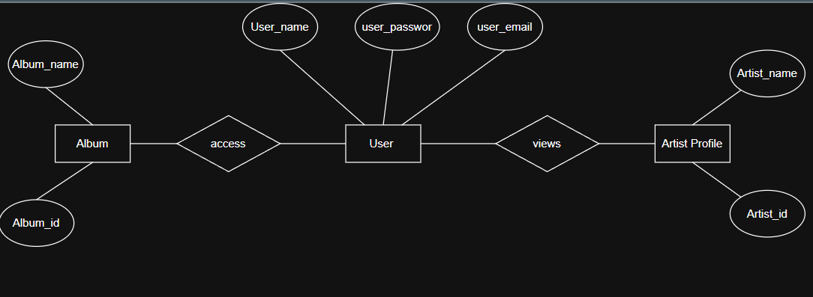

**3.2 DFD ( Data Flow Diagram ) LEVEL - 0:**

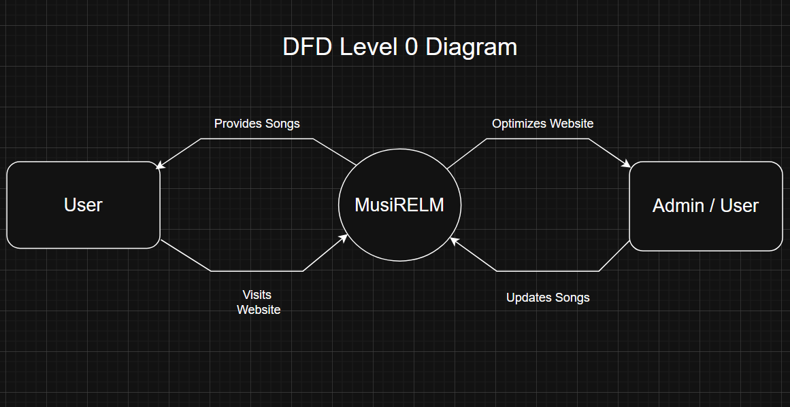

6

**3.3 User Interfaces ( Input and Output Screens )**

1. **Home Page:**

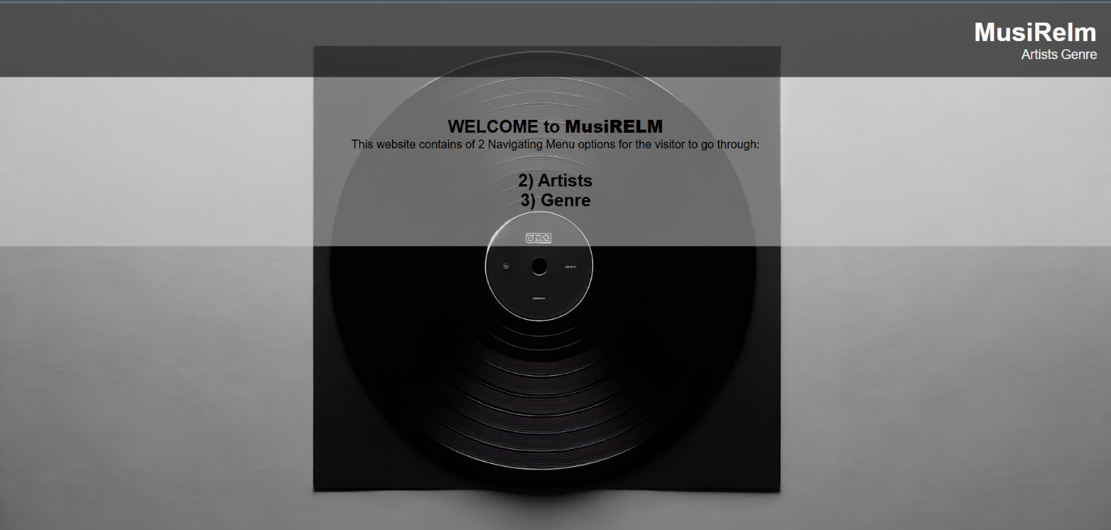

1. 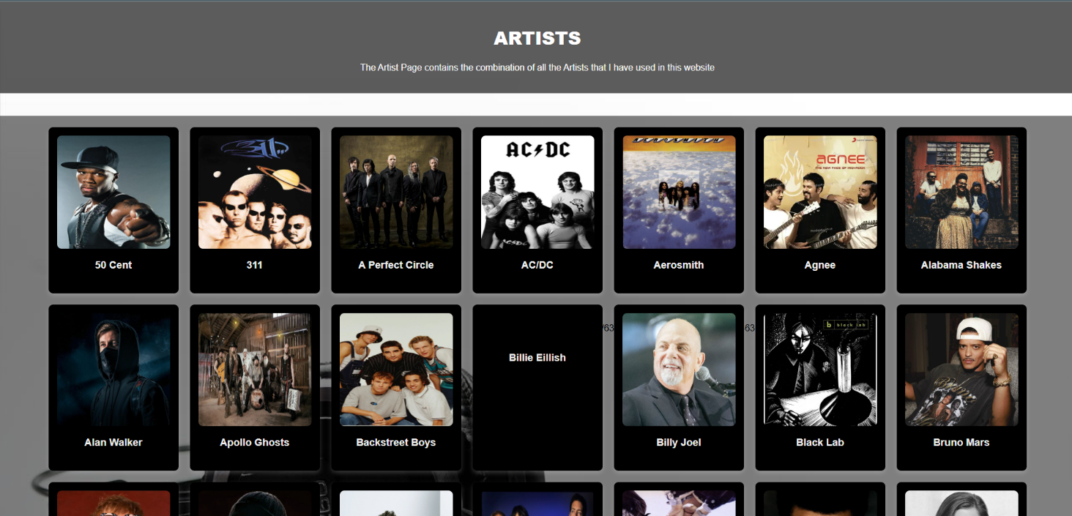**Artist Page :**

**7**

1. **Music Artist Profile Page – Artist Name in Image : Billy Joel**

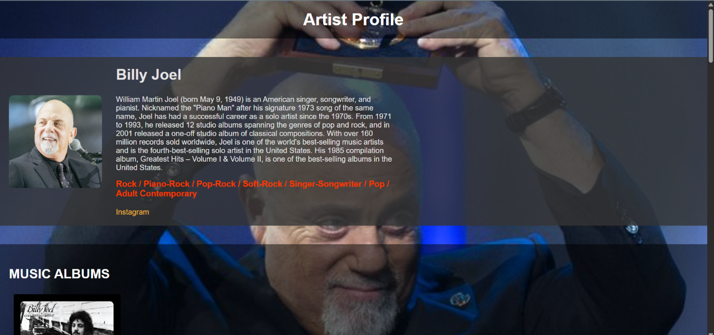

1. **Album Page – Albums by Billy Joel:**

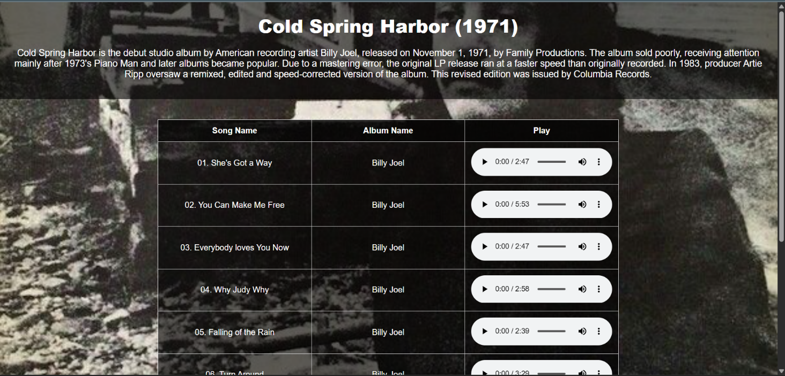

**8**

**CHAPTER 4 : USER MANUAL**

* 1. Future Enhancement:

**1.** **UI/UX Improvements:**

* Enhanced **navigation – adding a Music Navigation Bar.**
* Better **responsive design** for mobile/tablets.
* Adding **dark mode** or theme customization.

**2. Smart Personalization:**

* **AI-Powered Recommendations** – Suggest music based on user preferences.
* **Smart Playlists** – Auto-generate playlists based on mood, genre, or activity.
* **Lyrics Display** – Show synchronized lyrics while the song plays.

**3. Integration & Compatibility :**

* **Smart Device Support** – Work with smart speakers (Alexa, Google Home).
* **Mobile App Integration** – Sync progress between web & mobile app.
* **API Integration** – Support third-party apps or external music libraries.

**4. User Engagement & Social Features:**

* **User Profiles & Playlists** – Let users create & share playlists.
* **Comment & Like System** – Allow users to interact with songs.
* **Real-time Listening Parties** – Sync music playback with friends.

9

5.2 Bibliography:

* [https://open.spotify.com/?flow_ctx=5c6af8d3-582e-44fa-b5b7-99f0bd844190%3A1743673974#login](https://open.spotify.com/?flow_ctx=5c6af8d3-582e-44fa-b5b7-99f0bd844190%3A1743673974)
* <https://music.apple.com/us/new>
* <https://music.youtube.com/>
* Database Management Systems – for ERD – Rajiv Chopra
* Software Engineering – for 0 Level - Pankaj Jalote
* Web-Technology- For codes. - Rajiv Chopra.

**10**

5.4 ANNEXURE: Sample Program Code:

1. Home Screen Program :

<!DOCTYPE html>

<html lang="en">

<head>

<meta charset="UTF-8">

<meta name="viewport" content="width=device-width, initial-scale=1.0">

<title>My Music Website</title>

</head>

<body>

<header>

<div class="logo">

<h1>MusiRelm</h1>

</div>

<nav>

<ul>

<li><a href="C:\Users\Sarthak Kulkarni\Documents\MusiRelm - MINI PROJECT\MINI Project\2) Artist Section\Artists Section.html">Artists</a></li>

<li><a href="C:\Users\Sarthak Kulkarni\Documents\MusiRelm - MINI PROJECT\MINI Project\3) Genre Section\Genre CG.html">Genre</a></li>

</ul>

</nav>

</header>

<section id="home" class="hero">

<h1>WELCOME to <b>MusiRELM</b></h1>

<p>This website contains of 2 Navigating Menu options for the visitor to go through:<br><h2><br>2) Artists<br>3) Genre</h2></p>

</section>

</body>

</html>

**11**

1. Artist Profile Program:

<!DOCTYPE html>

<html lang="en">

<head>

<meta charset="UTF-8">

<meta name="viewport" content="width=device-width, initial-scale=1.0">

<title>Artists Page</title>

<head>

**</head>**

**<body>**

**<header>**

**<h1><b>ARTISTS</b></h1>**

**<p>The Artist Page contains the combination of all the Artists that I have used in this website</p>**

**</header>**

**<!-- Artists Section -->**

**<section class="artists-section">**

**<div class="artists-list">**

**<div class="artists">**

**<img src="https://i.pinimg.com/736x/c6/30/a7/c630a742eac394b15ed44f9fecb7f186.jpg" alt="50 Cent">**

**<a href="C:\Users\Sarthak Kulkarni\Documents\MusiRelm - MINI PROJECT\MINI Project\2) Artist Section\50 Cent ( AP ).html">**

**<h4>50 Cent</h4>**

**</a>**

**</div>**

**</div>**

**</section>**

**</body>**

**</html>**

**12**

1. **Albums Page :**

<!DOCTYPE html>

<html lang="en">

<head>

<meta charset="UTF-8">

<meta name="viewport" content="width=device-width, initial-scale=1.0">

<title>Artist Page</title>

</head>

<body>

<!-- Header Section -->

<header>

<h1>Artist Profile</h1>

</header>

<!-- Artist Profile Section -->

<section class="artist-profile">

<img src="https://i.pinimg.com/736x/c6/30/a7/c630a742eac394b15ed44f9fecb7f186.jpg">

<div class="info">

<h2>50 Cent</h2>

<p>Curtis James Jackson III (born July 6, 1975),known professionally as 50 Cent, is an American rapper, actor, and television producer. Born in South Jamaica, a neighborhood of Queens, Jackson began pursuing a musical career in 1996. In 1999–2000, he recorded his debut album Power of the Dollar for Columbia Records; however, he was struck by nine bullets during a shooting in May 2000, causing its release to be cancelled and Jackson to be dropped from the label. His 2002 mixtape, Guess Who's Back?, was discovered by Detroit rapper Eminem, who signed Jackson to his label Shady Records, an imprint of Dr. Dre's Aftermath Entertainment and Interscope Records that same year.</p>

<p>Jackson has sold over 30 million albums worldwide and earned several accolades, including a Grammy Award, a Primetime Emmy Award, thirteen Billboard Music Awards, six World Music Awards, three American Music Awards and four BET Awards.</p>

<p class="genre">Pop/Hip-Hop/Pop Rap/Hardcore Hip-Hop/Gangsta Rap</p>

<div class="social-links">

<a href=>Instagram</a>

</div>

</div>

</section>

**13**

<!-- Albums Section -->

<section class="albums-section">

<h3>MUSIC ALBUMS</h3>

<div class="album-list">

<div class="album">

<img src="https://i.pinimg.com/736x/ec/22/78/ec227887370abca54f0dc85199f653a3.jpg" alt="Album Cover">

<a href="C:\Users\Sarthak Kulkarni\Documents\MusiRelm - MINI PROJECT\MINI Project\2) Artist Section\50 Cent ( AP )\1) Get Rich Or Die Tryin'.html">

<h4>Get Rich or Die Tryin' (2003)</h4>

</a>

</div>

</div>

</section>

</body>

</html>

**14**